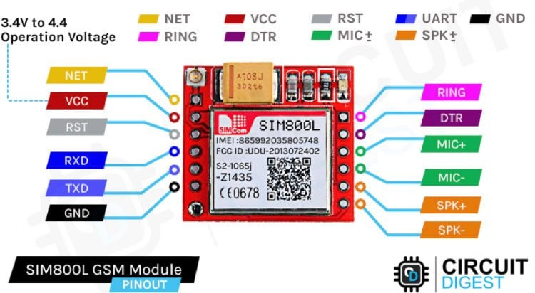

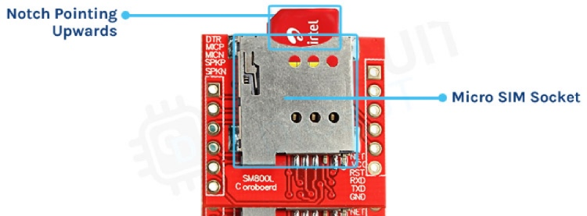

Sending SMS in SIM800L GSM Module Working
The SIM800L module supports making calls and sending messages.
Below is the Arduino code for sending a message on the SIM800L. You just need to change the phone number (+XXXXXXXXXXXX)and the text that you need to send, and upload the code.
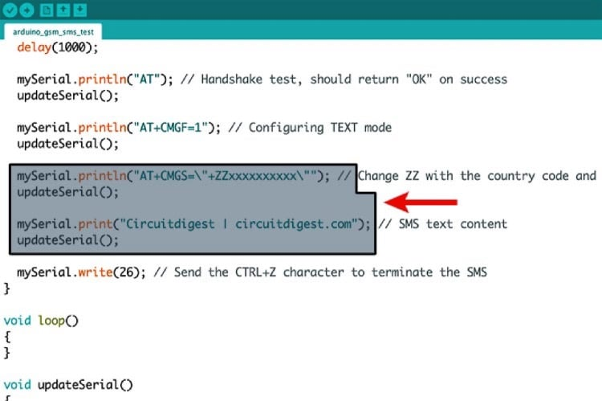

SIM800L GSM Module Arduino Code
Here’s the complete SIM800L SMS Arduino code for the same.
#include <SoftwareSerial.h>
// Create a SoftwareSerial object to communicate with the SIM800L module
SoftwareSerial mySerial(3, 2); // SIM800L Tx & Rx connected to Arduino pins #3 & #2
void setup()
{
// Initialize serial communication with Arduino and the Arduino IDE (Serial Monitor)
Serial.begin(9600);
// Initialize serial communication with Arduino and the SIM800L module
mySerial.begin(9600);
Serial.println("Initializing...");
delay(1000);
mySerial.println("AT"); // Handshake test, should return "OK" on success
updateSerial();
mySerial.println("AT+CMGF=1"); // Configuring TEXT mode
updateSerial();
mySerial.println("AT+CMGS=\"+ZZxxxxxxxxxx\""); // Change ZZ with the country code and xxxxxxxxxxx with the phone number to send an SMS to
updateSerial();
mySerial.print("Circuitdigest | circuitdigest.com"); // SMS text content
updateSerial();
mySerial.write(26); // Send the CTRL+Z character to terminate the SMS
}
void loop()
{
}
void updateSerial()
{
delay(500);
while (Serial.available())
{
mySerial.write(Serial.read()); // Forward data from Serial to Software Serial Port
}
while (mySerial.available())
{
Serial.write(mySerial.read()); // Forward data from Software Serial to Serial Port
}
}
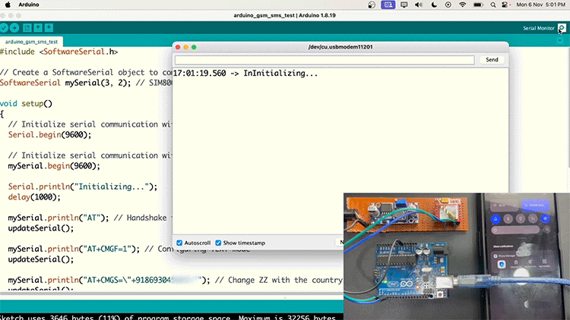
If your SIM800L is not sending SMS, check with the SIM card network provider if 2G SMS is available on their network.

Making Calls on SIM800L Using Arduino
Now, let’s test the call feature. Copy and paste the code given below and change the phone number given in the code (+XXXXXXXXXXXX) with your recipient's number.
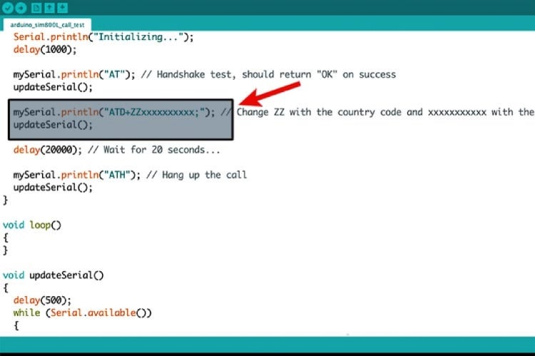
Here’s the complete SIM800L GSM module Arduino code where you need to make the changes.
#include <SoftwareSerial.h>
// Create a SoftwareSerial object to communicate with the SIM800L module
SoftwareSerial mySerial(3, 2); // SIM800L Tx & Rx connected to Arduino pins #3 & #2
void setup()
{
// Initialize serial communication with Arduino and the Arduino IDE (Serial Monitor)
Serial.begin(9600);
// Initialize serial communication with Arduino and the SIM800L module
mySerial.begin(9600);
Serial.println("Initializing...");
delay(1000);
mySerial.println("AT"); // Handshake test, should return "OK" on success
updateSerial();
mySerial.println("ATD+ZZxxxxxxxxxx;"); // Change ZZ with the country code and xxxxxxxxxxx with the phone number to dial
updateSerial();
delay(20000); // Wait for 20 seconds...
mySerial.println("ATH"); // Hang up the call
updateSerial();
}
void loop()
{
}
void updateSerial()
{
delay(500);
while (Serial.available())
{
mySerial.write(Serial.read()); // Forward data from Serial to Software Serial Port
}
while (mySerial.available())
{
Serial.write(mySerial.read()); // Forward data from Software Serial to Serial Port
}
}
Now, upload the code and your recipient should receive a call.
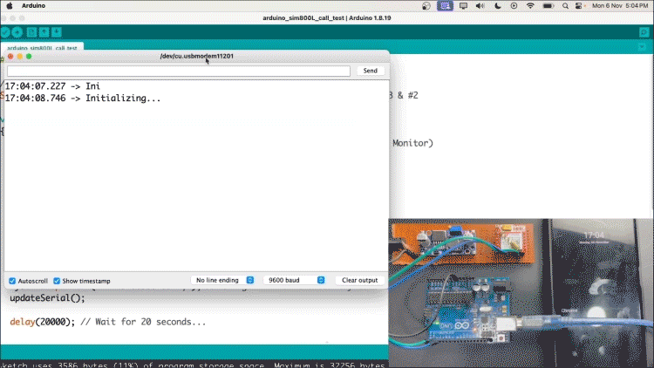
Note:- You can reset the Arduino to make the call again. The same goes for messages

Technical summary and GitHub Repository
Here’s the GitHub repo where you can find the complete code and the circuit diagram. We have also provided an overview of a project's key components, implementation details, and functionality, typically covering the hardware/software architecture and design decisions that we have used in this tutorial.

